Assignment #2. CSS Styling
Arman Adilbek
Index.html (Main Page)
Create a central homepage with navigation to all tasks.
1.The <header> contains the project title and <nav> with links to task1.html, task2.html, task3.html, and task4.html.
2.In <main> there is a short welcome message and description of the project.
3.The <footer> shows the author’s name and year.
4.In main.css the style is consistent: light blue background, white content box, blue header navigation.
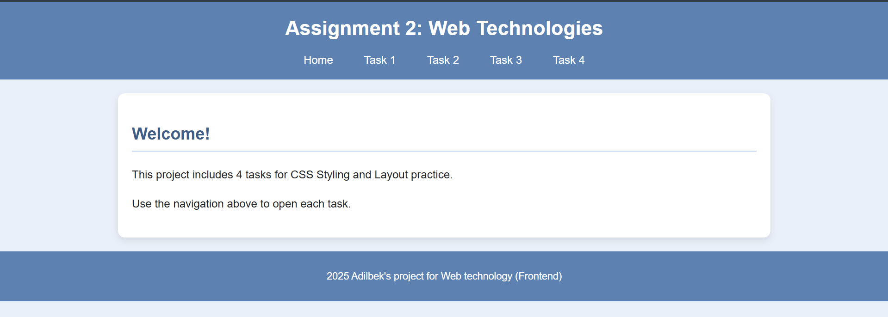
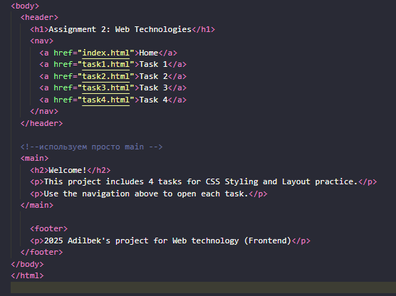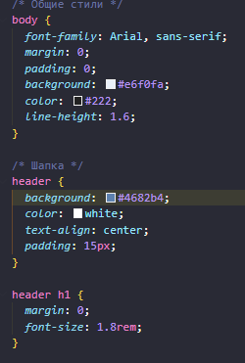

Task 1 – iPhone 17 Store
Build a simple online store layout.
1.The <header> contains the store name and navigation menu.
2.The <main class="layout"> is divided into:
- <aside class="sidebar"> — filters (color and storage) using <input type="radio"> and <input type="checkbox">.
- <section class="content"> — the product list.
3.Inside the content, products are shown as cards (.product-card) with image, title, price, and a “Buy Now” button.
4. In main.css:
- .layout uses display: flex to place sidebar and content side by side.
- .product-grid creates a responsive grid of cards.
- Blue color theme for consistent design.
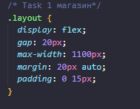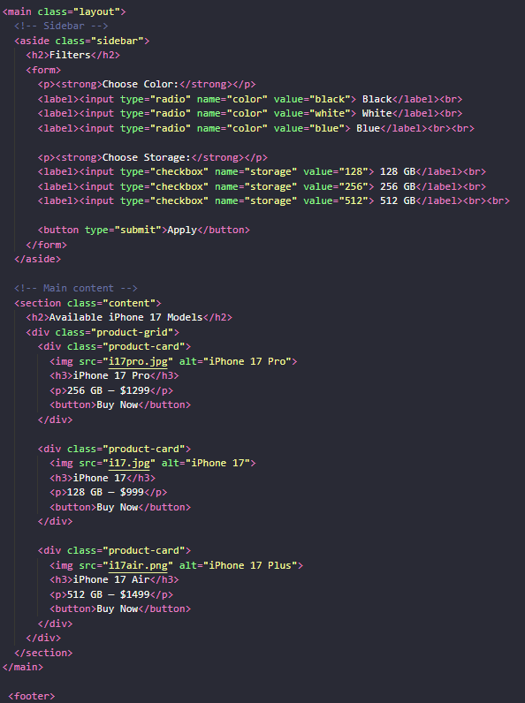

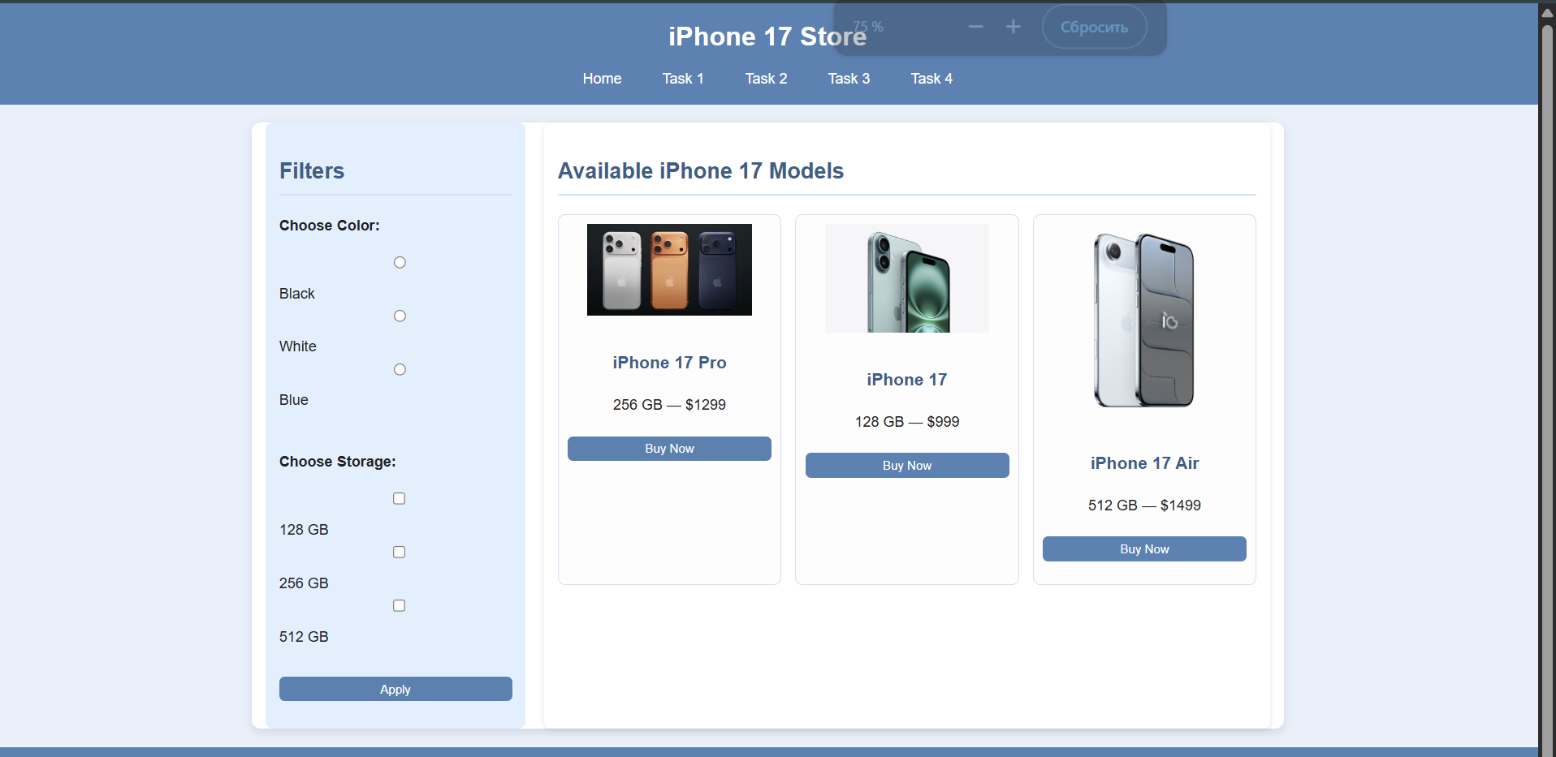
Task 2 – Muhammad Ali Tribute Page
Create a tribute page for a famous person (Muhammad Ali).
1.In <header> we added Muhammad Ali’s name and subtitle “The Greatest of All Time.”
2. <main> has three sections:
- About — short biography.
- Important Events — list of milestones in <ol>.
- Contributions — list of achievements in <ul>.
3.In .image-section we placed an image, a caption, and a Wikipedia link.
4.Navigation in the header is the same as in other tasks.
5.main.css provides styles: white content box with shadow, blue headers, framed image, styled button link.
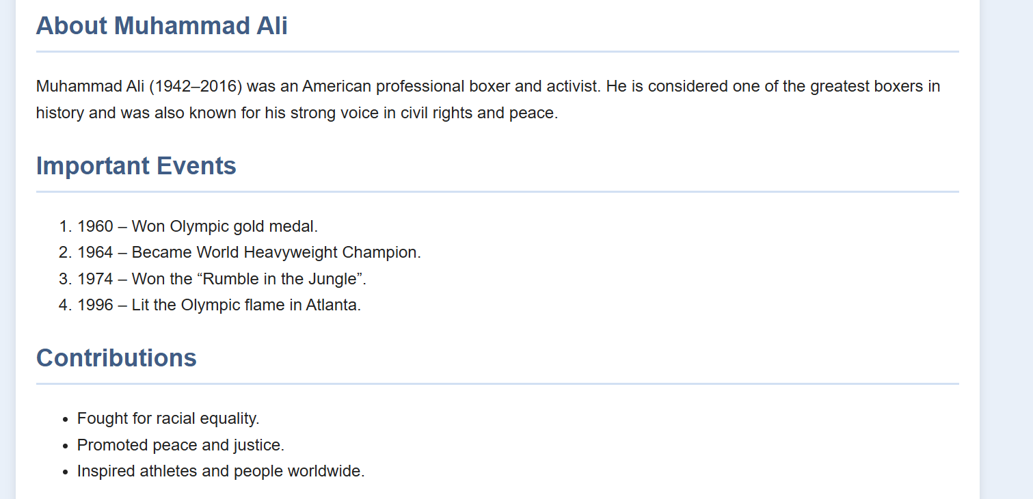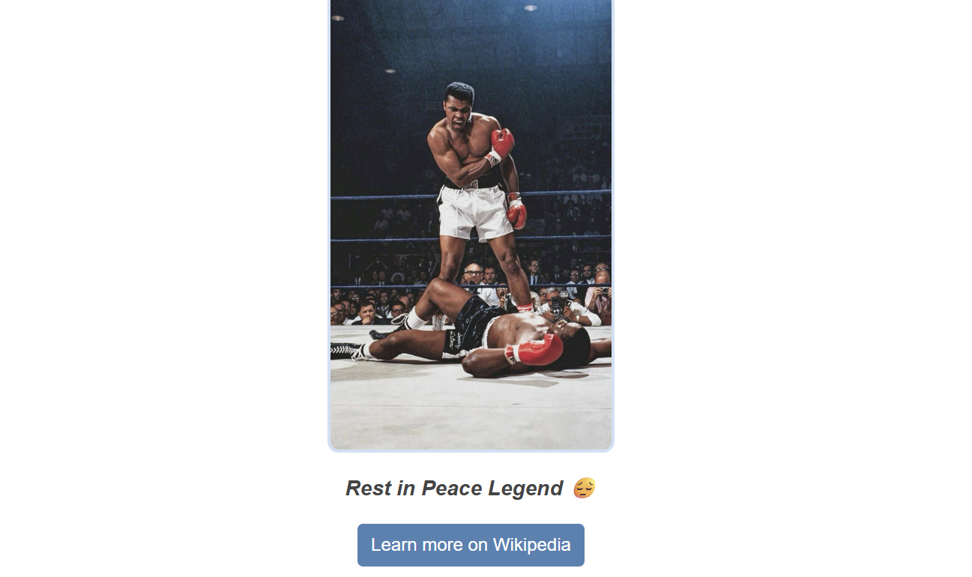
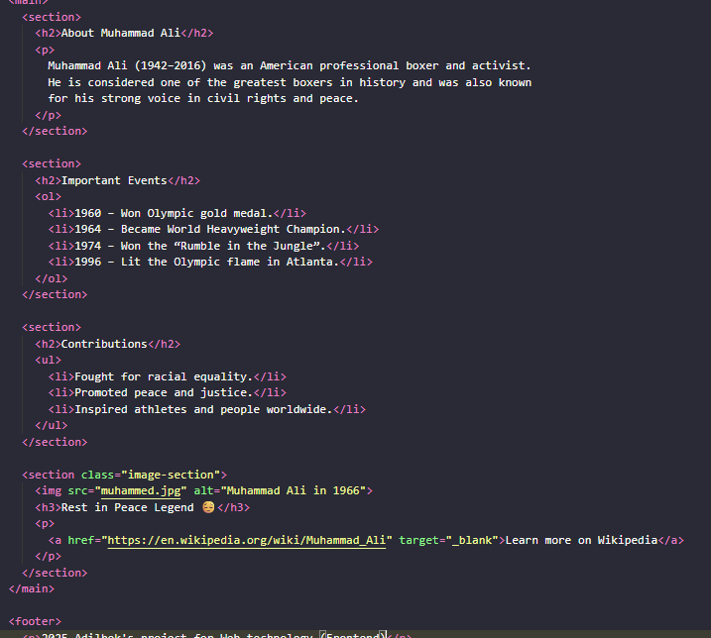
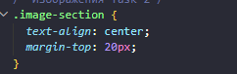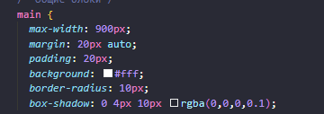

Task 3 – Table & Feedback Form
Create a page with a table and a feedback form.
1.In <header> we have the title and navigation.
2.<main> includes:
- A <table> showing students, subjects, and grades. One row is highlighted with .highlight-row.
- A <form> containing:
  - Name (text input)
  - Email (email input)
  - Role (dropdown <select>)
  - Radio buttons (Yes/No)
  - Comment field (<textarea>)
  - Submit button
3.In main.css:
- Table uses border-collapse and alternating row colors (nth-child(even)).
- Headers have a blue background.
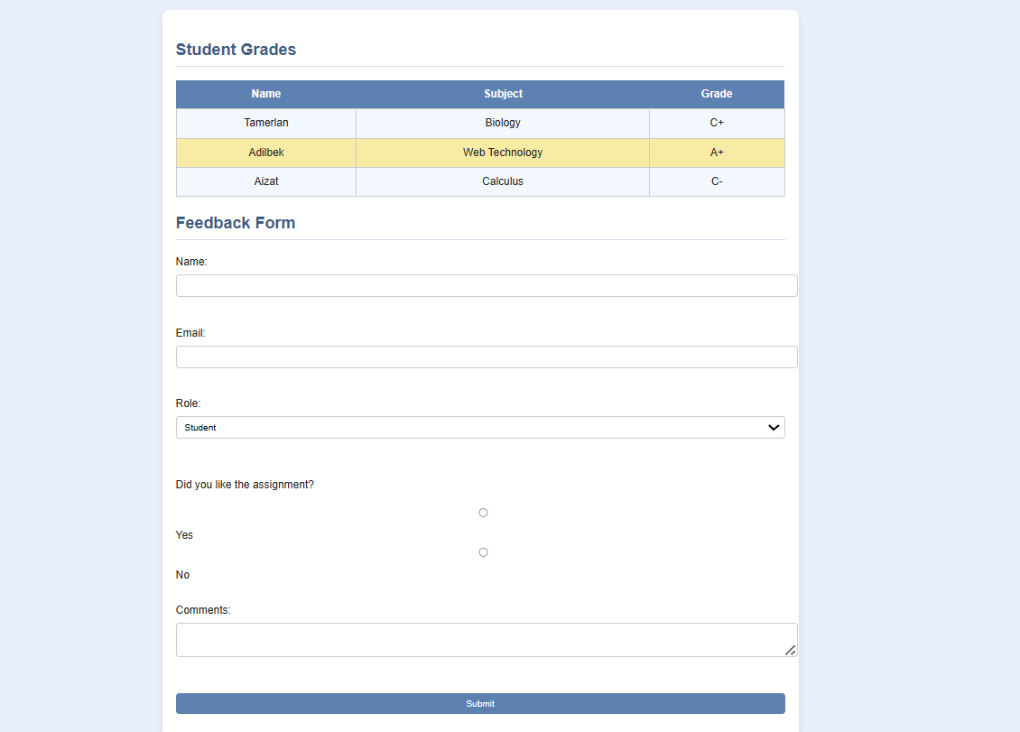

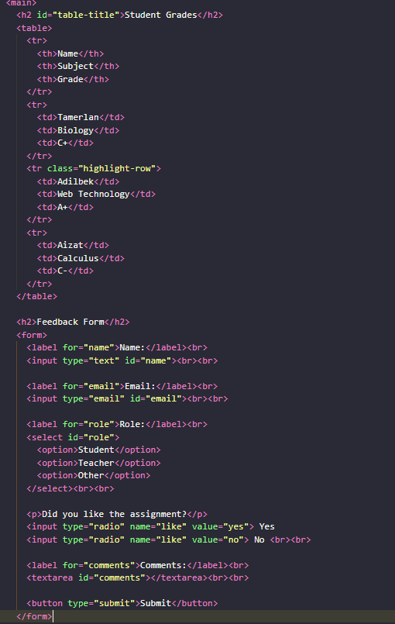
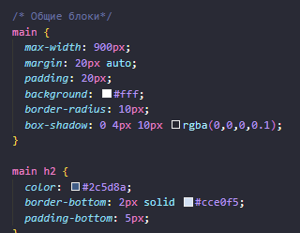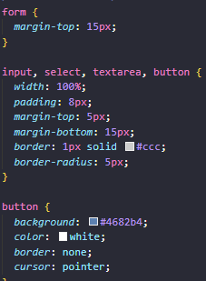

Task 4 – Hotel Booking
Create a basic hotel booking webpage.
1.In <header> we added the title and navigation.
2.<main> includes:
- Welcome message introducing the hotel.
- A list of available rooms (<ul>).
- A booking <form> with fields:
  - Full Name
  - Email
  - Room Type (<select>)
  - Check-in Date (<input type="date">)
  - Check-out Date (<input type="date">)
  - Submit button (“Book Now”)
3.In main.css:
- Forms are styled with consistent input and button design.
- Blue button with hover effect for interactivity.
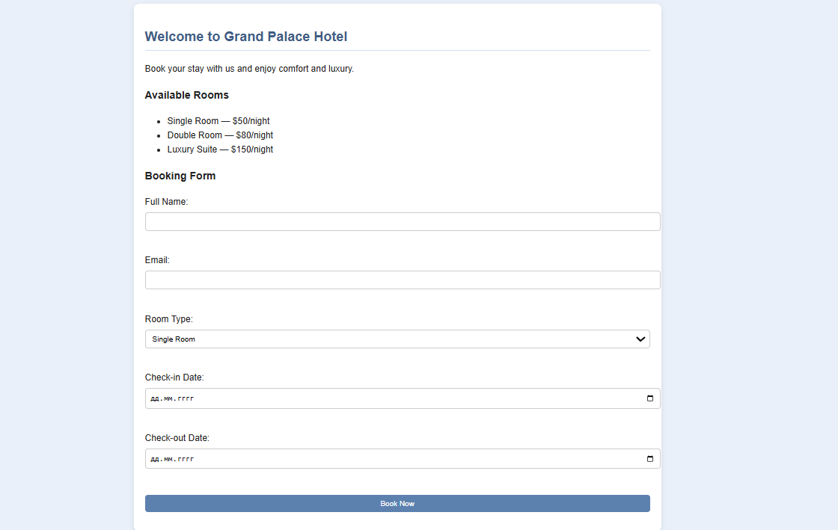
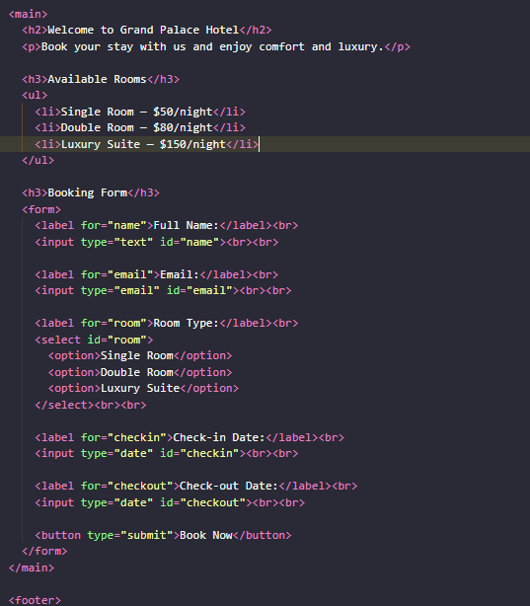

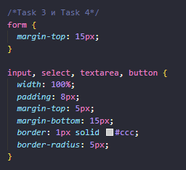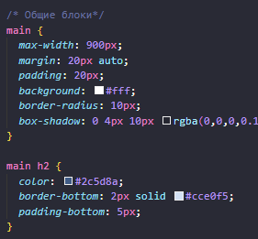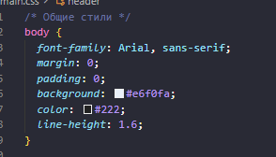
Conclusion
- All pages share the same header, navigation, and footer for consistency.
- The common stylesheet (main.css) ensures a unified design: light blue background, white content cards, and blue buttons.
- Each task demonstrates a different concept:
  - Task 1 — Store layout.
  - Task 2 — Tribute Page.
  - Task 3 — Table + Feedback Form.
  - Task 4 — Hotel Booking.

